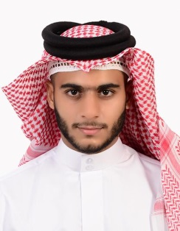 **WADIA MOHAMED MAKI ALI SALMAN FARHAN**

000702366

Tel.+973- 34174411-39869878

Email: Wadih93@gmail.com

Date : of Birth:JULY-8-2000

Marital Status: singleImmediately

**EDUCATIONAL AND EXPRAINCE QUALIFICATION**

2018-2019 Secondary School Degree **.**

Hamed town secondary school (literary) **.**

Bahrain boxing coaching examination **.**

**Skills**

**Computer skills :** - Microsoft office

**Teamwork** : - ability to prioritize

- Assign tasks

- Make decisions promptly

**Work skills** : - working in welding

- Works in electricity and carpenter life experiences

- Working knowledge in English and Arabic

**Analytical** : - the ability to identify problems

- Self confidence

- Perfect problem – solving skills

**Experience**: - secretary

-Driver

**other**

runnig - -

swimming -